
REPUBLIC OF CAMEROON REPUBLIQUE DU CAMEROUN
************************ **************************
PEACE-WORK-FATHERLAND PAIX-TRAVAIL- PATRIE
*********************** ****************************

Course: C Programming
PKFOKAM INSTITUTE OF EXCELLENCE

PROJECT REPORT 1
Project Progress Report 1

GIT HUB REPOSITORY AND PERSON
MANAGEMENT CREATION

A
PROJECT
ND
TION
A
WEDDING INVIT
:

Framework | Django (Python 3.x)
Database | MySQL Restaurant DB
Architecture | MVT (Model-View-Template)
Modules | 5 functional modules
Team Size | 5 students

Group Members | Participation | Matricules
Talla Tchossi Daniella Elsa | 20% | 26S018
Djomo Yepdi Evans | 20% | 26S001
Matchim Dzuyim Verenne Celia | 20% | 26S031
Mekolle Tuatsop Dalhia Aure | 20% | 26S004
Messi Zang Paul Jacques | 20% | 26S005

Lecturer:

Mr. Mbietieu Amos

Mb
ieutieu

Academic Year:

202
5
–
202
6

- Project Overview…………………………………….

OUTLINE

- Development Tools Used…………………………..

- Work Organisation and task distribution…………..

- System Architecture………………………………….

- Functional Modules of the Application……………

- Main Difficulties Encountered………………………..

- Solutions Implemented………………………………

- Phase 1 Summary……………………………………

- Project Planning(GANTT PROJECT)…………………

System Design
- Class diagram…………………………………………
- Use case Diagram……………………………………
- Sequence Diagram………………………………………
- Deployment Diagram…………………………………

- GNU Image Manipulation ProgramToolkit (GTK) and Comma-Selected Value (CSV)…………………………….. …………….

- Problem Encountered and Solution…………………………….

- Conclusion……………………………………………………..
- References……………………………………………………….

1. Project Overview
The Wedding Invitation and Gift Management System (WIGMS) is a software application designed to assist in organizing and managing wedding events. Weddings in Cameroon often involve a large number of guests, gift contributions, and multiple social categories, which makes manual management difficult.
The purpose of this system is to simplify wedding planning by providing tools to manage:
- Guest information
- Social categories of guests
- Invitation priority
- Wedding gift tracking
The application is developed using the C programming language and follows a modular programming approach where each part of the system is implemented as an independent module.
The system aims to improve organization, reduce errors, and help wedding planners efficiently manage guest lists and gifts.

2. Development Tools Used
The following tools were used during the development of the system:
Tool | Purpose
C Programming Language | Main programming language used for system implementation
GCC Compiler | Used to compile and run the C programs
Visual Studio Code / CodeBlocks | Code editor for writing and debugging the program
GitHub | Version control and collaboration platform
Standard C Libraries  (stdio.h, ++ stdlib.h, string.h) | Used for input/output operations, memory management and string handling
These tools help ensure efficient development, collaboration, and proper project management.
3. Work Organisation and task distribution
The group consisted of 5 members. The work organisation depended on assigning responsibilities with respect to skills and the project phases. This approach permitted us to ensure that each section of this report would benefit from dedicated expertise.
Group Member | Main Role | Assigned Tasks
1. Matchim Dzuyim Verenne Celia | Implementation and testing | Common tasks: Project Overview, Development Tools Used, System Architecture, Phase 1 Summary. Individual tasks: GTK, CSV, Test of Person Management, Test of Category Management.
2. Mekolle Tuatsop Dalhia Aure | Documentation and planning | Common tasks: Project Overview, Development Tools Used, System Architecture, Phase 1 Summary. Individual tasks: Report 1, Gantt Project, Report 2, Implementation of Category Management.
3. Talla Tchossi Daniella Elsa | Development (core modules) | Common tasks: Project Overview, Development Tools Used, System Architecture, Phase 1 Summary. Individual tasks: GTK, CSV, Implementation of Person Management.
4. Messi Zang Paul Jacques | System design (UML diagrams) | Common tasks: Project Overview, Development Tools Used, System Architecture, Phase 1 Summary. Individual tasks: Use Case Diagram, Class Diagram.
5. Djomo Yepdi Evans | System modeling and deployment | Common tasks: Project Overview, Development Tools Used, System Architecture, Phase 1 Summary. Individual tasks: Sequence Diagram, Deployment Diagram.

4. System Architecture
The application follows a simplified modular architecture inspired by the MVC design pattern. The architecture consists of three main components:
- Model
The model contains the core data structures and logic of the program, including:
  - Person management
  - Category management
  - Priority management
  - Gift management
- Controller
The controller handles the flow of the application by managing the interactions between the user interface and the program modules.
- View
The view represents the interface presented to the user. In this project, the view is implemented through a console-based menu interface that allows the user to navigate through the different system functionalities.
This architecture ensures clear separation between data, logic, and user interaction.

5. Functional Modules of the Application
As first stage, we did what we consider as our Module 1: GitHub creation + Personal Management. This module focuses on:

Creating GitHub repository

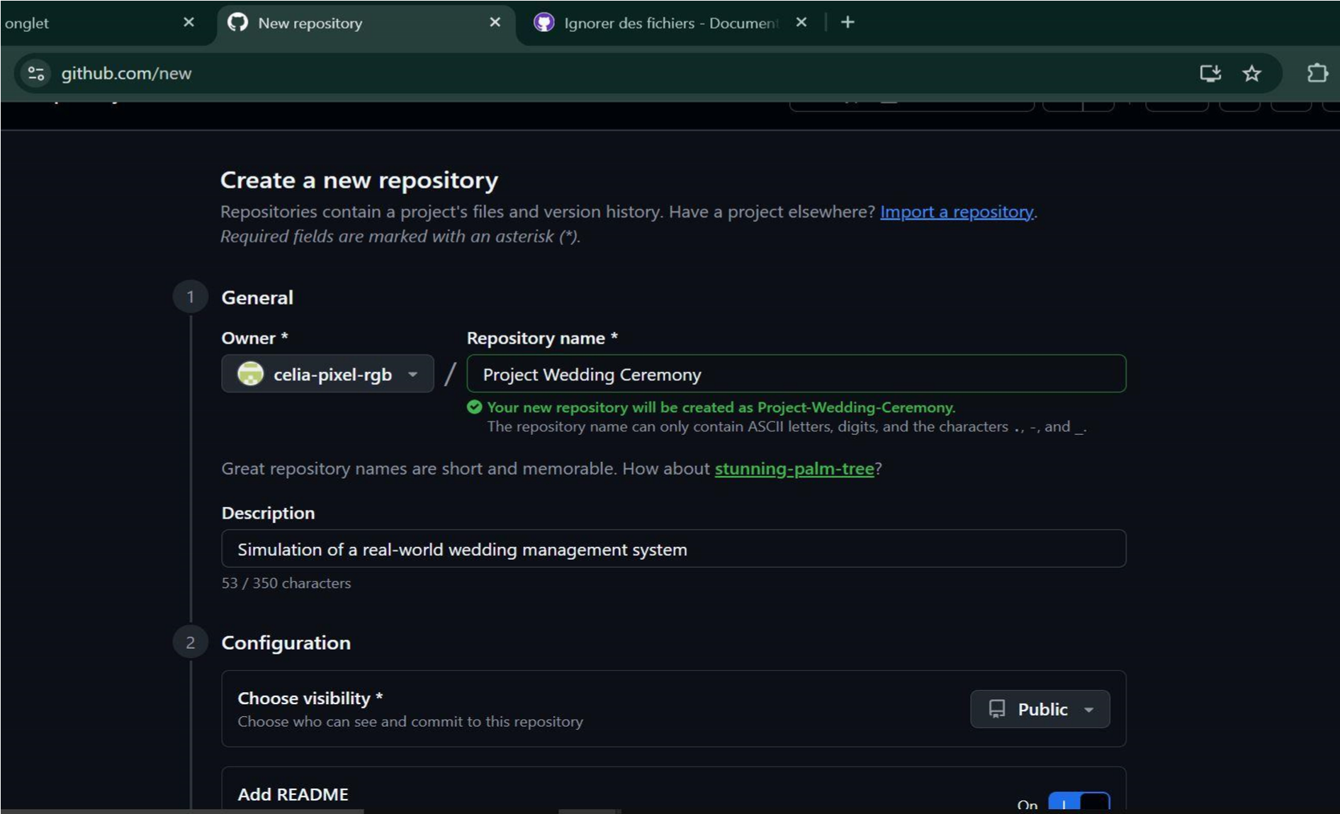
The group leader created the public repository with the following settings:
Here is the GitHub link to access our repository:
https://github.com/celia-pixel-rgb/Project-Wedding-Ceremony

SETTINGS | VALUE CHOSEN
Repository name | Project-Wedding-Ceremony
Visibility | Public
.gitignore | C template selected
Repository link | https://github.com/celia-pixelrgb/Project-Wedding-Ceremony
Adding Collaborators
The remaining group members were added as collaborators through the
Setting --» collaborators page of the repository. Each member received an Email invitation from GitHub which they accepted in order to gain push access to the repository.
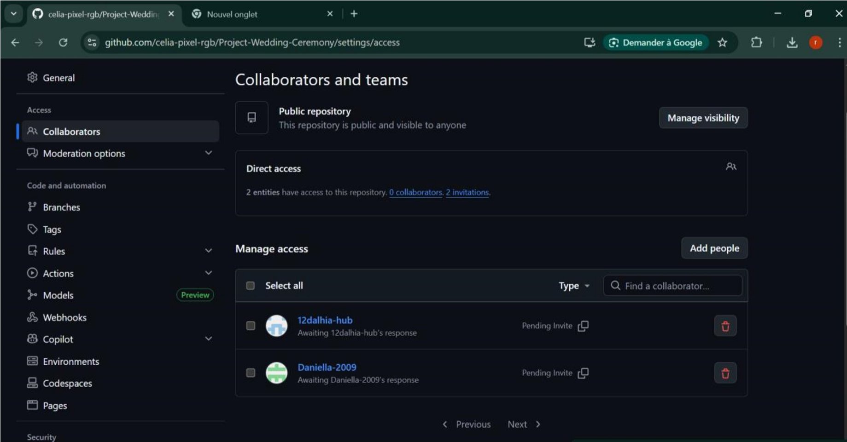

➢ Cloning the Repository and first Push
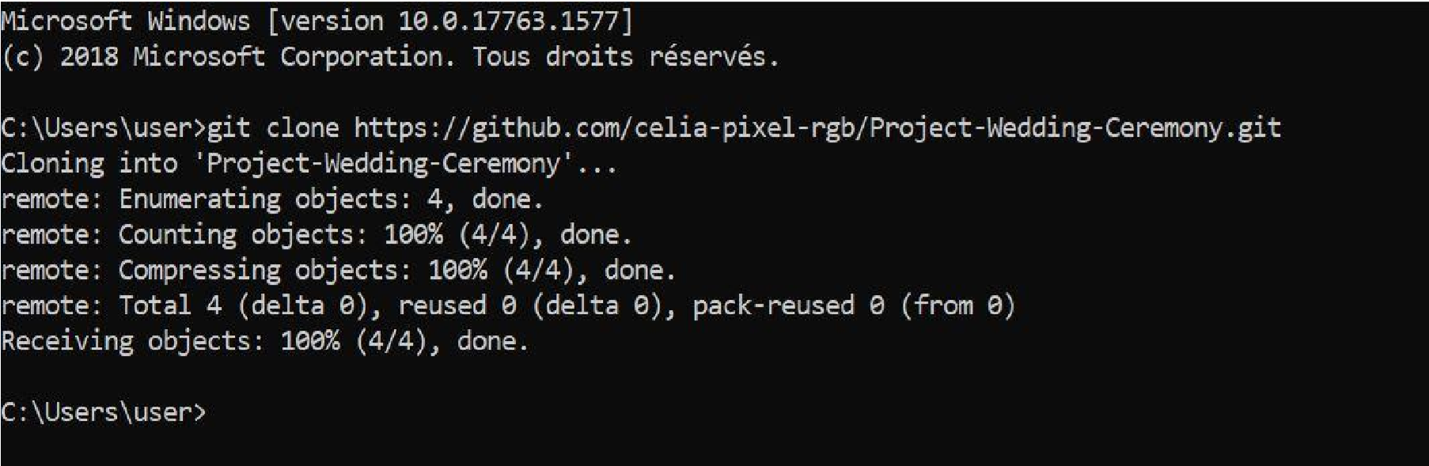
After accepting their invitation, each member cloned the depository into their local machine. The group leader then performed the first push of the program.

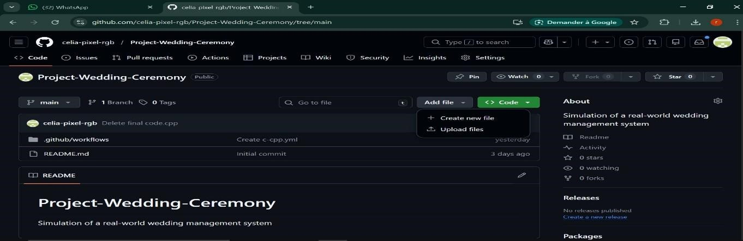
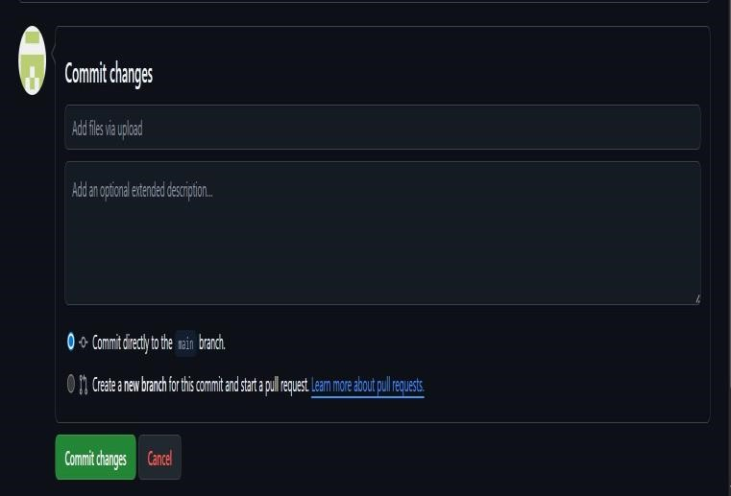
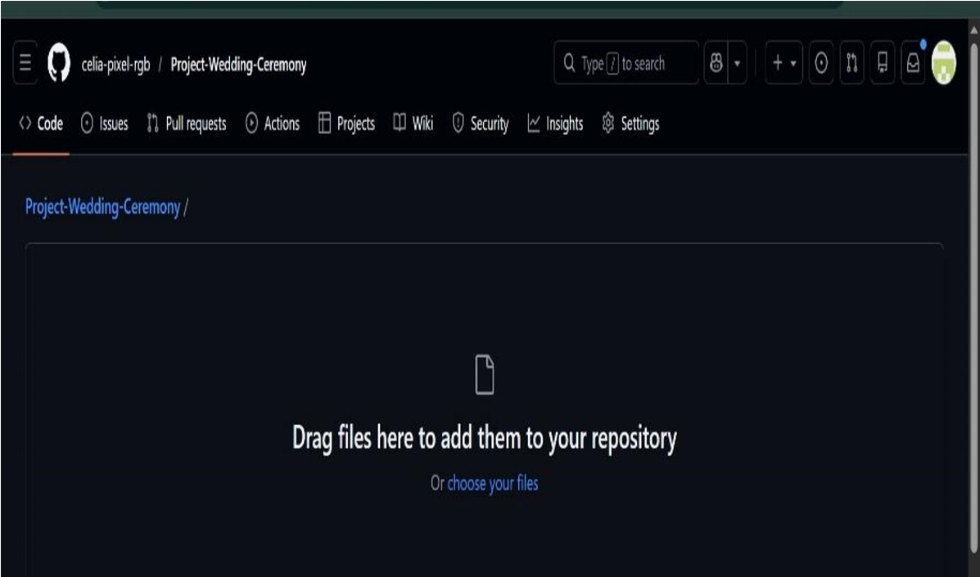

Creation of the c program to manage the guests
This module manages guest information. It allow the system to:
- Create a new guest
Here, we are creating a program that can create persons (guests). Based on the wanted total number of guests entered by the user, we defined a structure in which we register guests base on their name, age, Id, social status and their side (either the bride or the groom).
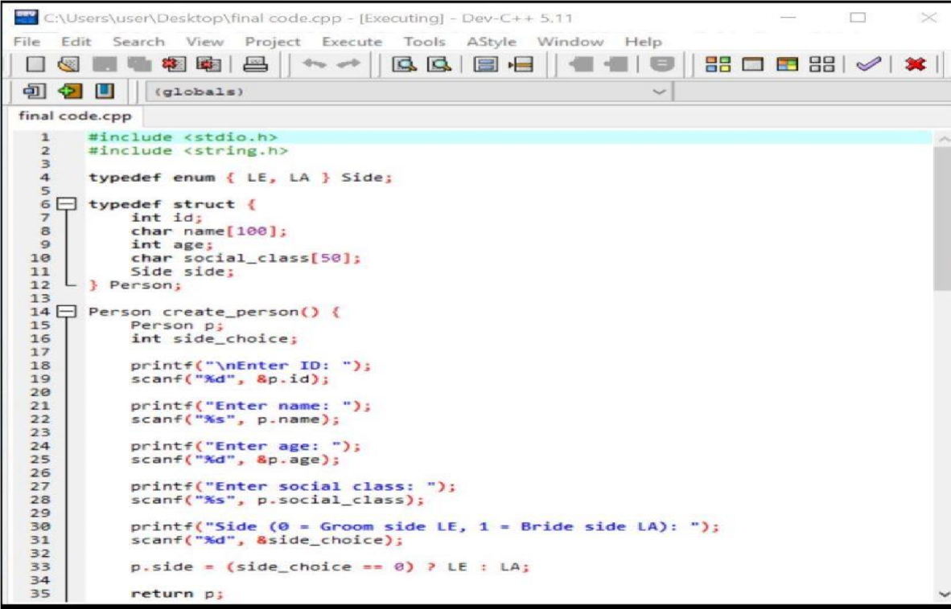
.

Display the guest
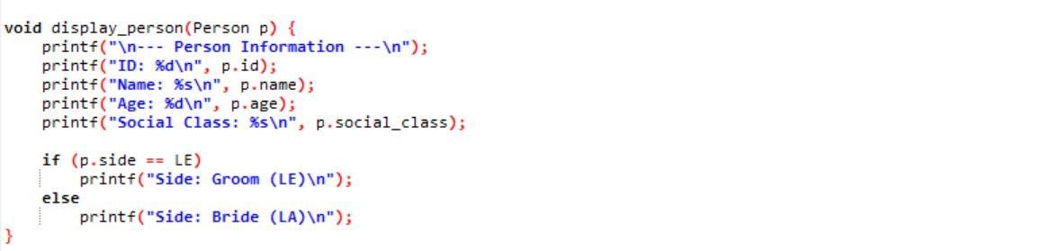
•

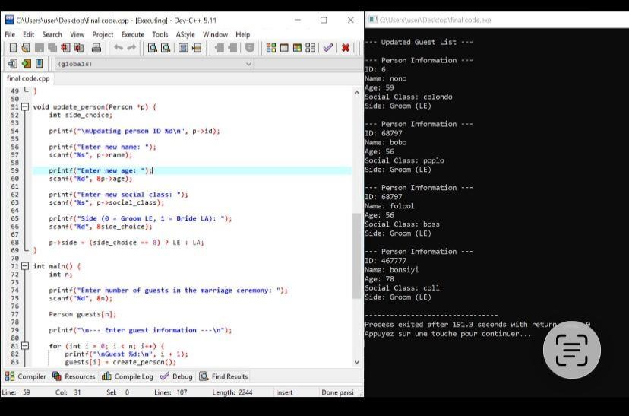
Update Guest

6. Main Difficulties Encountered
During the development of the project, several challenges were encountered:
- Understanding the use of structures in C programming
- Correctly implementing alternatives structures, loops and memory management
- Designing linked list structures for dynamic data
- Managing user input validation
- Debugging errors during program execution
These challenges required careful testing and collaboration among team members.

7.Solutions Implemented
To address the difficulties encountered, the following solutions were implemented:
- Reviewing C programming documentation and tutorials
- Testing each function independently before integration
- Using debugging techniques to identify program errors
- Collaborating through GitHub to track and fix problems
These solutions allowed the team to successfully implement the first module of the project.

8. Phase 1 Summary
The first phase of the project was successfully completed.
The team was able to:
- Understand the project requirements
- Set up the development environment
- Create the project structure
- Implement the Person Management module
- Test the system functionality
The project is now ready to proceed to the next phase, which will involve implementing additional modules that we will present later on.

8. References
The following references were used during the development of this project:
- Brian W. Kernighan & Dennis M. Ritchie – The C Programming Language
- Stephen Prata – C Programming: A Modern Approach
- ISO C Programming Documentation
- GitHub Official Documentation – https://docs.github.com
- Course materials provided by the lecturer

9.Gantt Project
This project outlines the planning, design, and implementation of a software system using structured project management techniques. The Gantt chart was used to organize tasks, timelines, and dependencies efficiently.

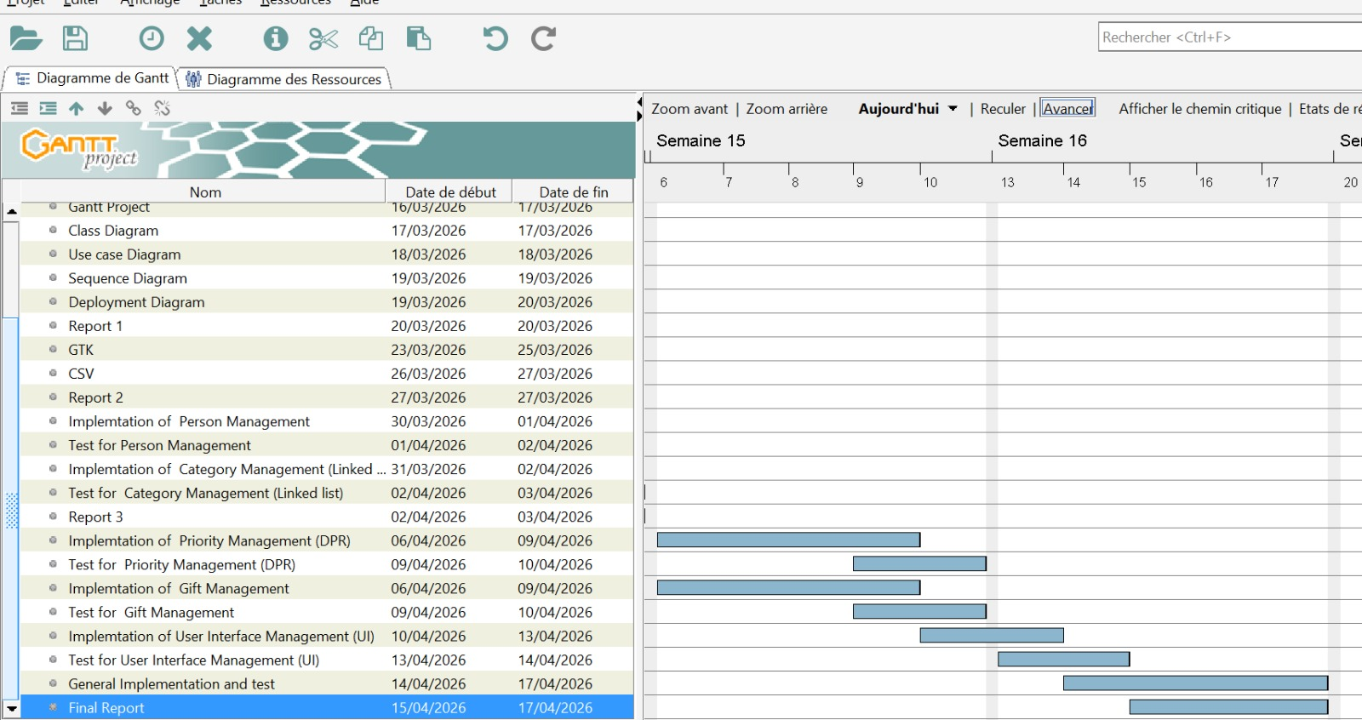
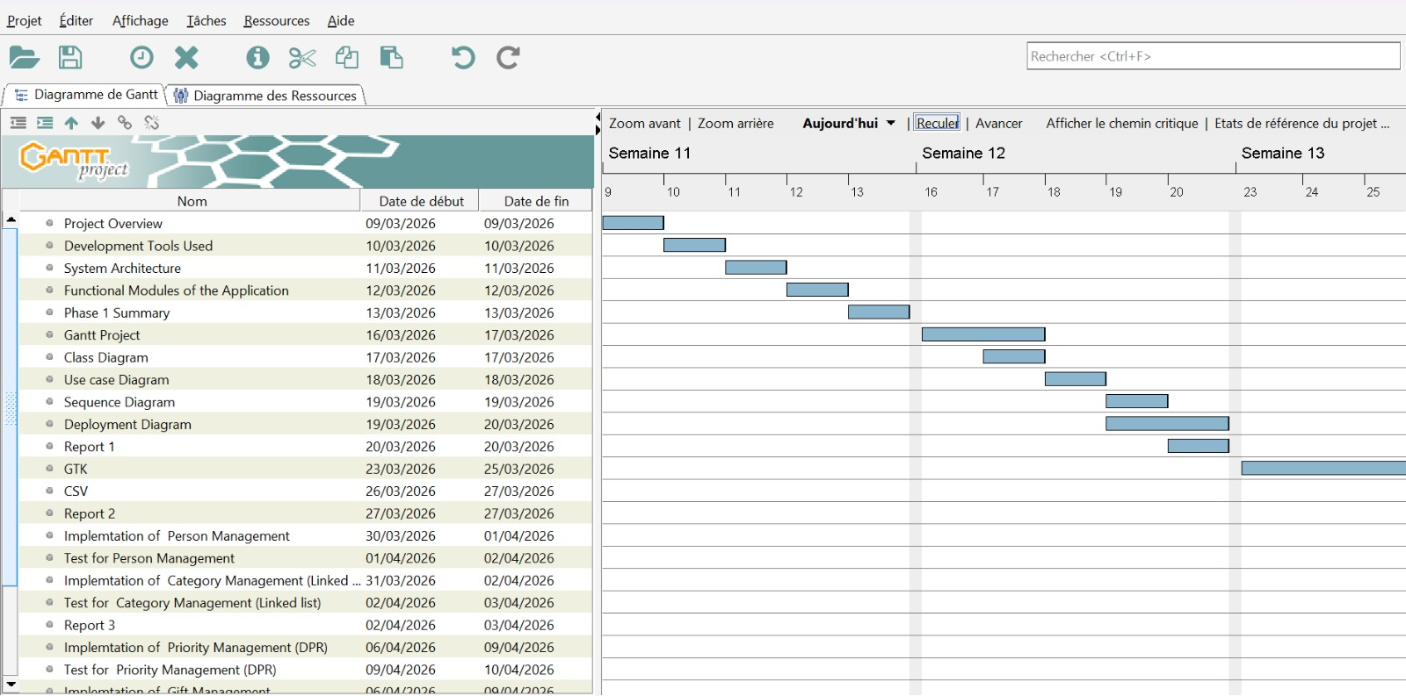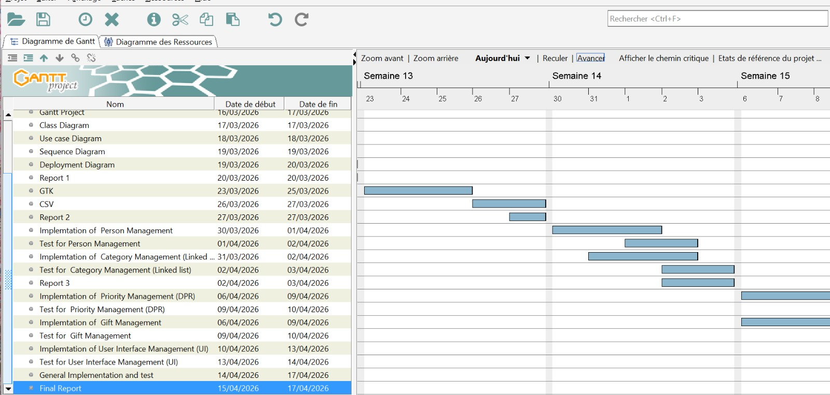

Phase |  | Key Activities | Outcome
Phase 1: Project Initiation & Planning |  | Project overview, identification of development tools, system architecture design | Clear understanding of project scope, tools, and technical structure
Phase 2: System Design |  | Functional modules definition, class diagram, use case diagram, sequence diagram, deployment diagram | Well-structured system design and interaction models
Phase 3: Project Documentation & Setup |  | Phase 1 summary, Gantt project creation | Organized documentation and project scheduling
Phase 4: Core Implementation |  | Implementation of person management, category management (linked list), priority management (DPR), gift management | Functional backend modules developed successfully
Phase 5: Testing & Validation |  | Testing of person, category, priority, and gift management modules | Identification and correction of system errors
Phase 6: User Interface Development |  | Implementation and testing of user interface (UI) | User-friendly interface ensuring system usability

Conclusion
The project was successfully structured using a Gantt chart, ensuring proper time management and task coordination.
All phases were completed systematically, resulting in a functional and well-tested application.

SYSTEM DESIGN
System design is a critical phase in software development that defines the structure, components, and interactions of a system. It provides a clear blueprint to guide the development process and ensure that all functional and technical requirements are met.
In this section, we will present and explain the key design diagrams used in the project, including the class diagram, sequence diagram, deployment diagram, and use case diagram, to illustrate how the system operates and how its components interact.
CLASS DIAGRAM
Overview
The WIGMS UML Class Diagram models wedding organization entities using StarUML. A central Wedding class connects nine supporting classes — each with detailed attributes and defined relationships via UML associations and multiplicity notation.
- A class diagram provides a static view of the system, showing classes, attributes, operations, and relationships.
- In WIGMS, it acts as a blueprint for implementation.
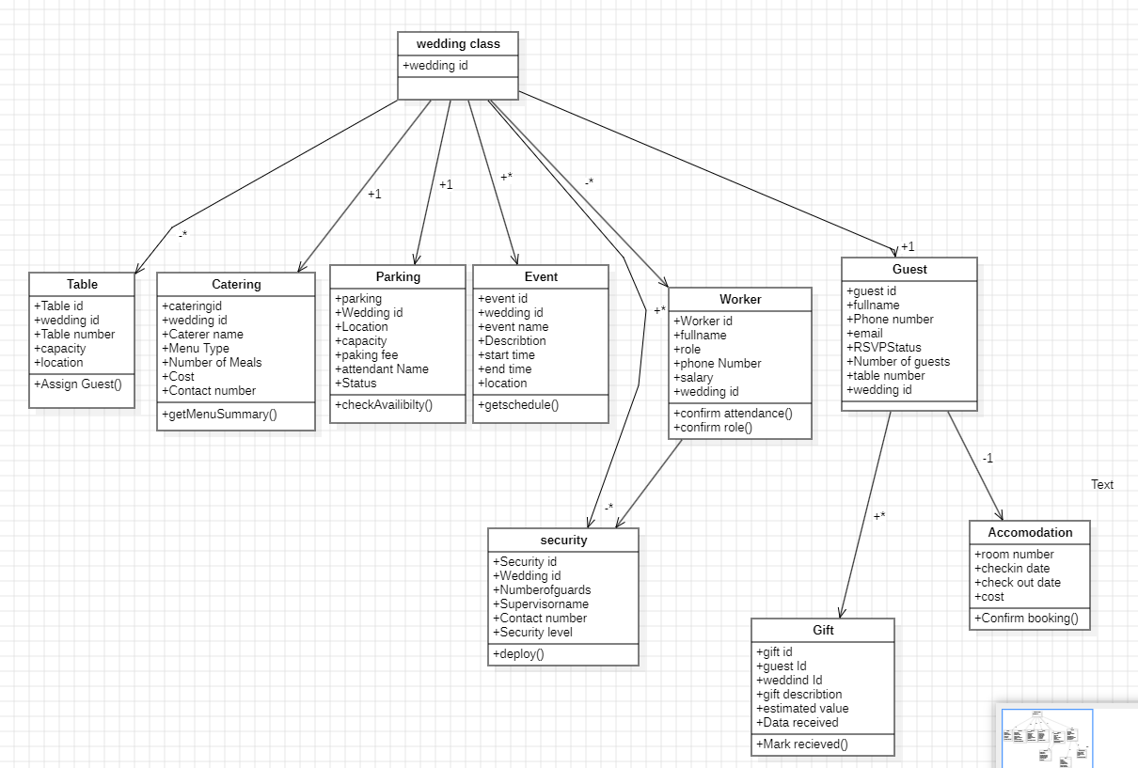
- The model contains ten main classes: Wedding, Guest, Worker, Security, Catering, Parking, Event, Table, Gift, and Accommodation. The Wedding class is the central hub linking all other elements.

- Class Diagram

USE CASE DIAGRAM
Overview
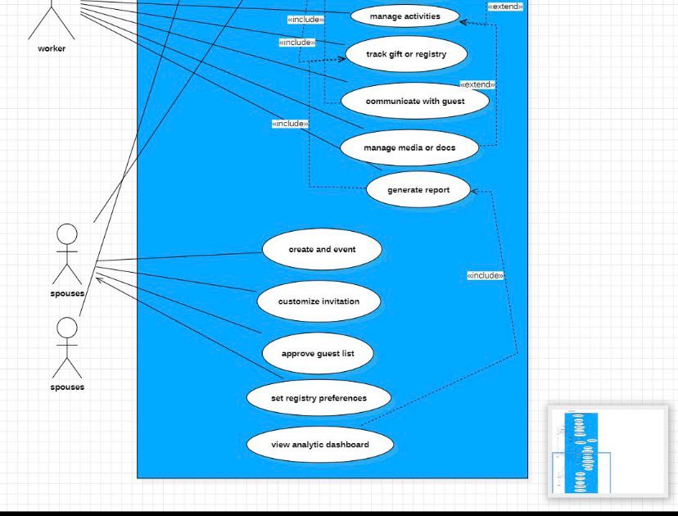
The WIGMS Use-Case Diagram models how users interact with the Wedding Invitation and Gift Management System. Designed in StarUML, it identifies two actors (Guest and Worker), maps their use cases, and defines system boundaries using «include» and «extend» relationships. The system reflects real-life wedding planning, particularly in the Yaoundé context.
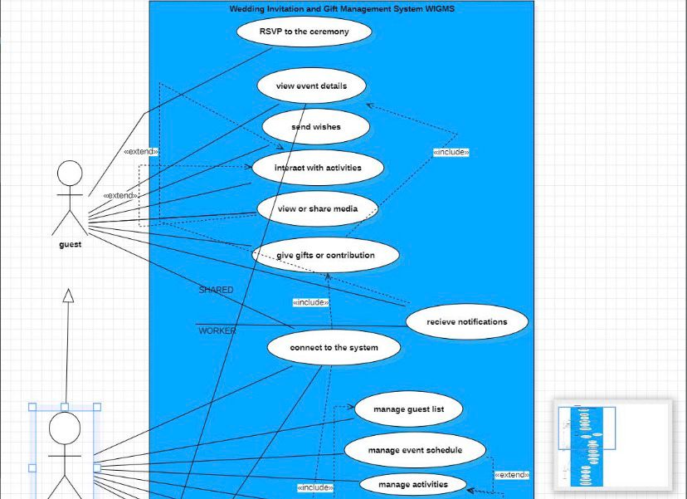
Actor | Role | Key Interactions
Guest | External wedding attendees. | RSVP, view event details, send wishes, give gifts, interact with activities, view/share media, receive notifications
Spouses | The wedding couple — primary system owners. | Create event, customise invitation, approve guest list, set registry preferences, view analytics, receive notifications
Worker | Event staff handling back-end operations. | Manage guest list, event schedule, activities, gifts, media/docs, communicate with guests, generate reports
- Use-case Diagram

SEQUENCE DIAGRAM

Overview
A sequence diagram illustrates how different components of the wedding-planning system interact over time through ordered message exchanges.
It helps visualize the workflow of actions such as event creation, guest invitations, and RSVP tracking, ensuring processes occur in the correct sequence.
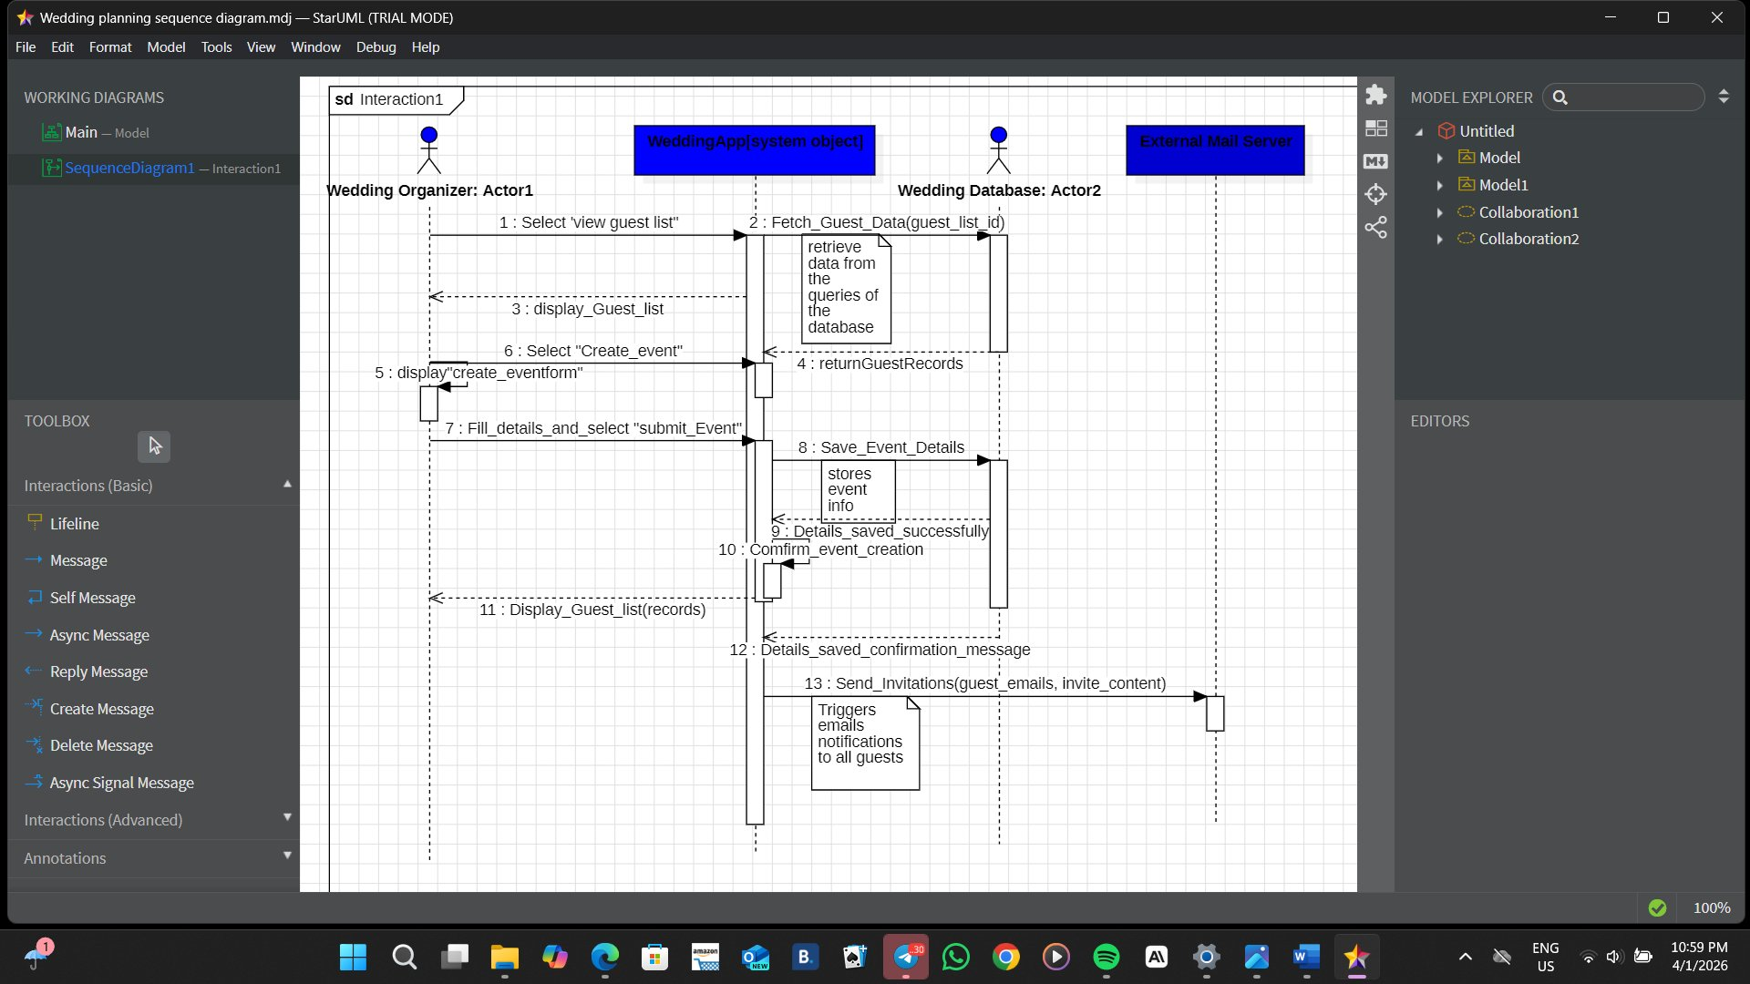

Figure 1: Sequence Diagram — Wedding Management System (StarUML)

DEPLOYMENT DIAGRAM

Deployment Diagram
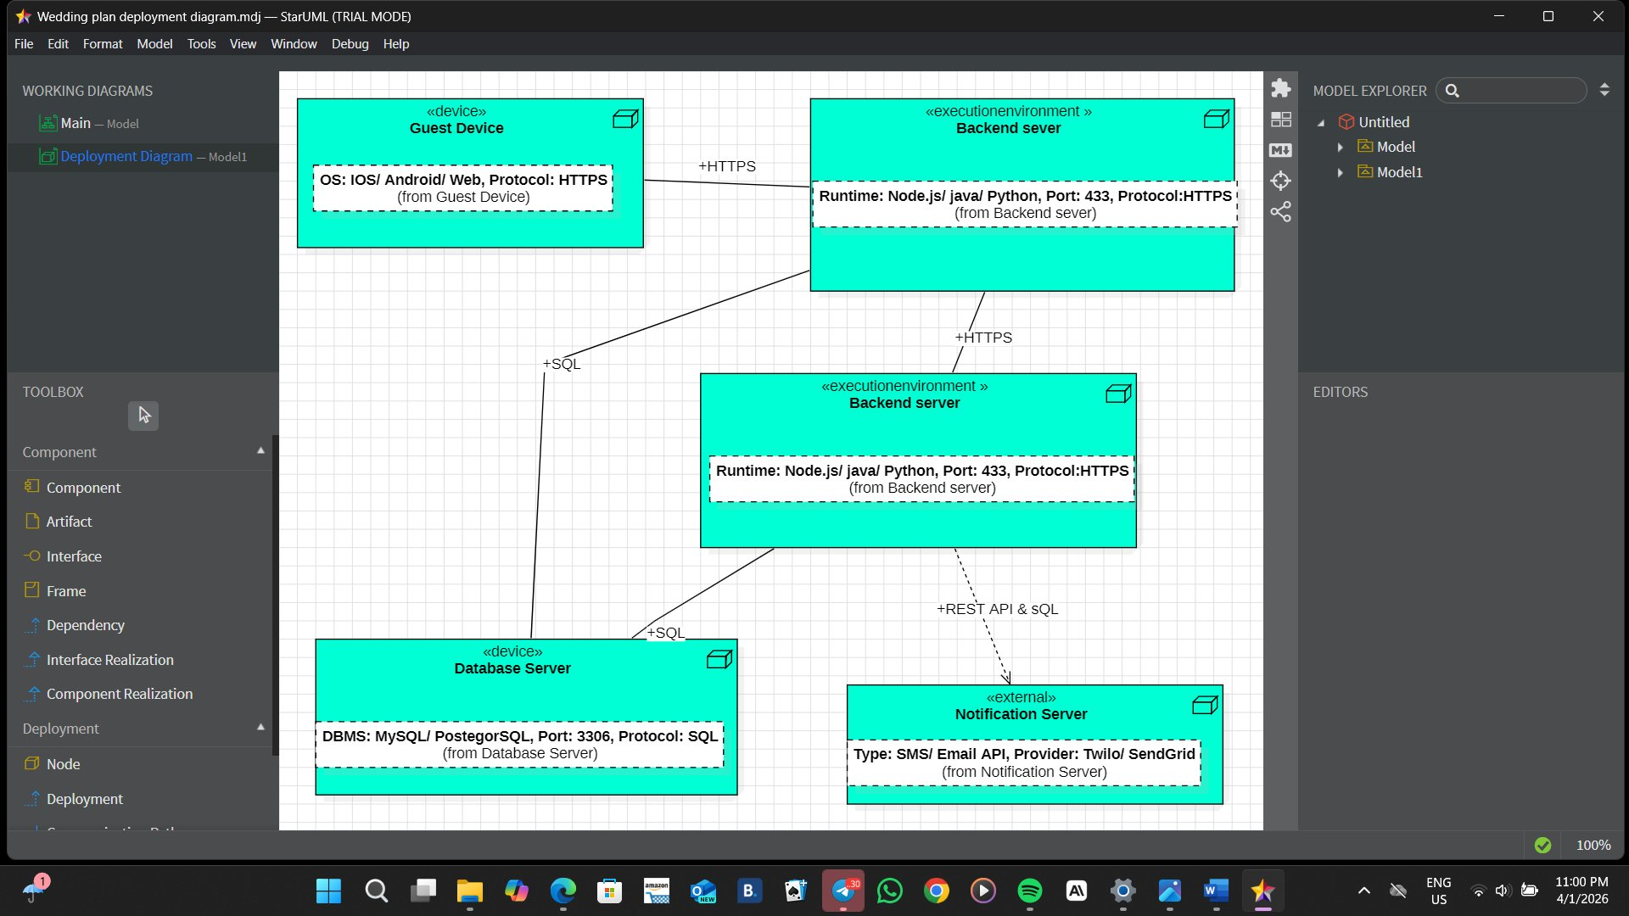

Figure 2: Deployment Diagram — Wedding Management System (StarUML)

- GNU Image Manipulation ProgramToolkit (GTK) and Comma-Selected Value (CSV

GTK
Development of a GTK-based form application written in C for managing wedding guest data. The application collects user input through a graphical interface and stores it in a CSV file.
Program Overview
The program uses GTK4 to create a graphical interface consisting of input fields for Name, Age, Status, Phone, and Side. A Save button allows users to store the entered data into a CSV file named guests.csv.

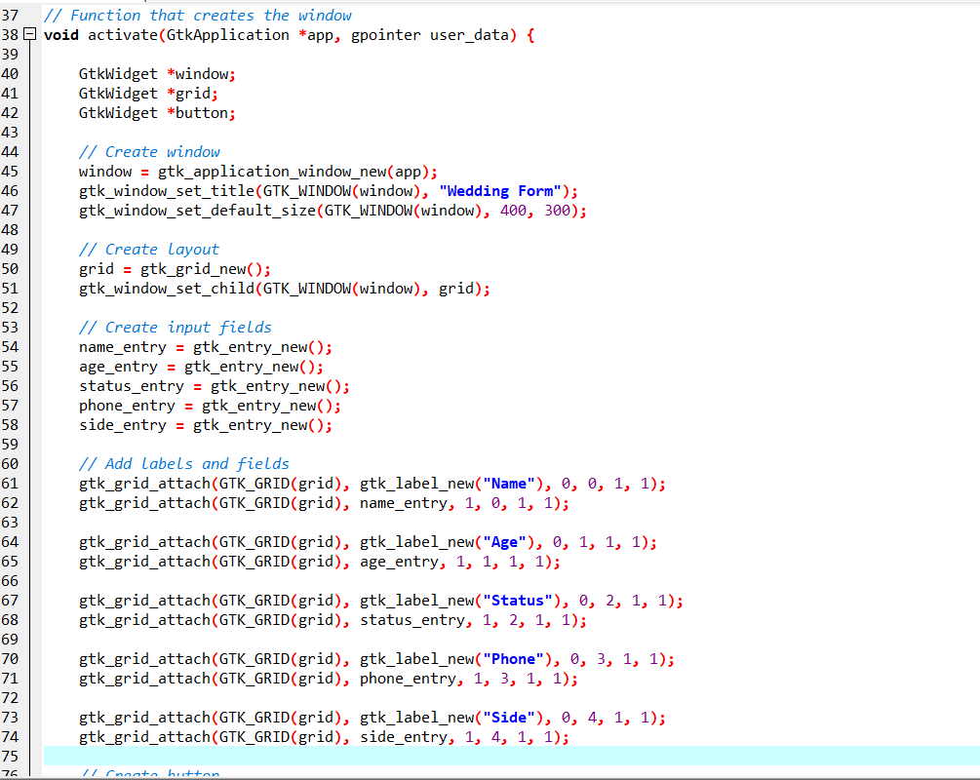
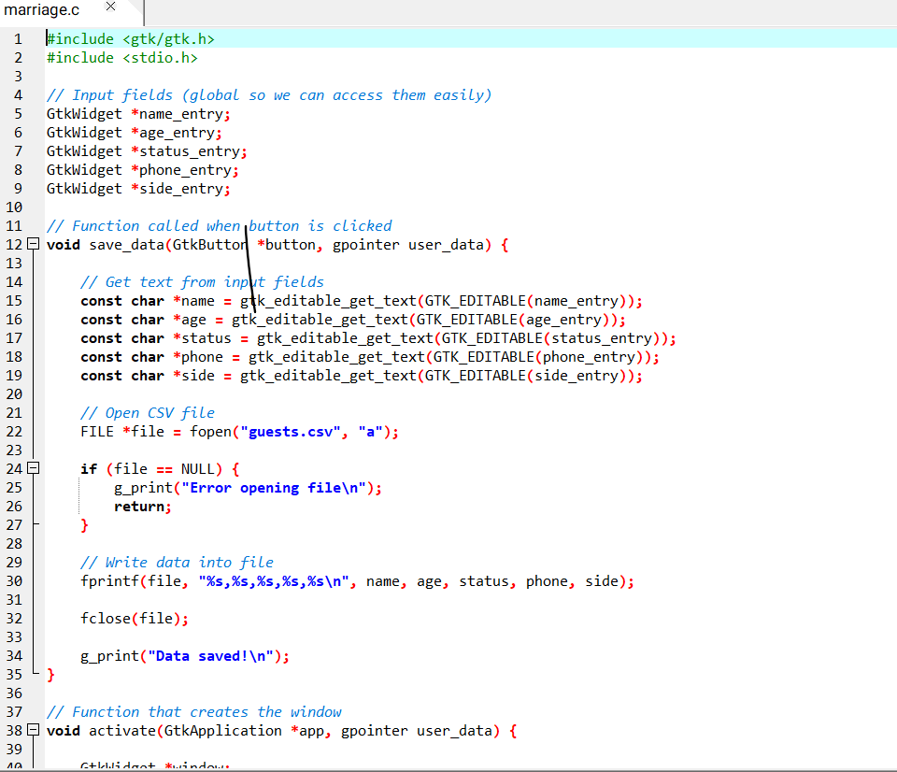
Key Implementation Details

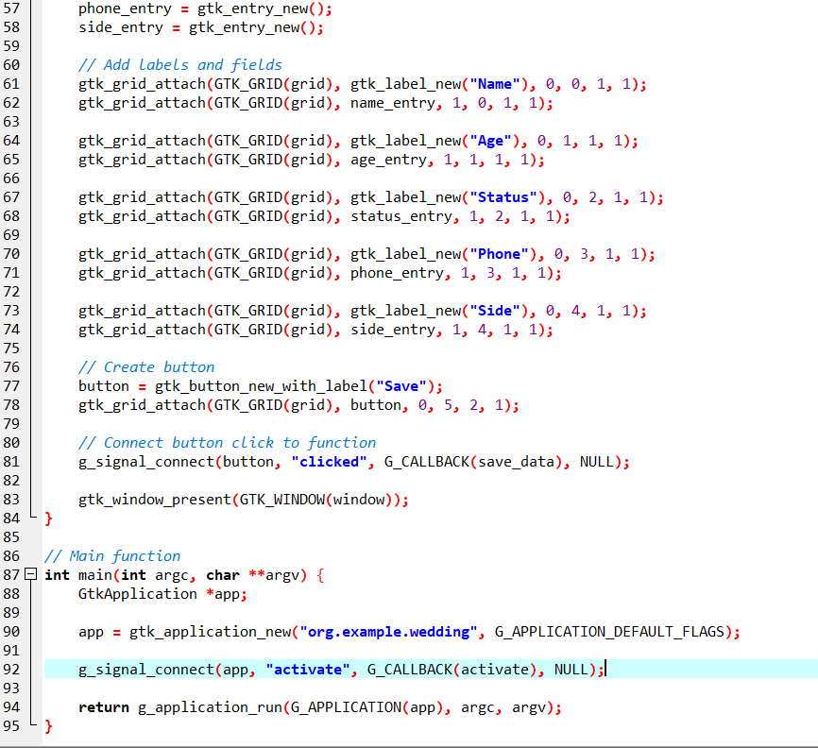

- Global widget pointers were used to allow access to input fields across functions. This simplifies retrieving user input when the Save button is clicked.
- The use of gtk_editable_get_text() allows extraction of user input from each entry field. This is required because GTK widgets do not directly expose their content.
- File handling is implemented using fopen in append mode ("a").
This ensures that new data is added without overwriting existing entries.
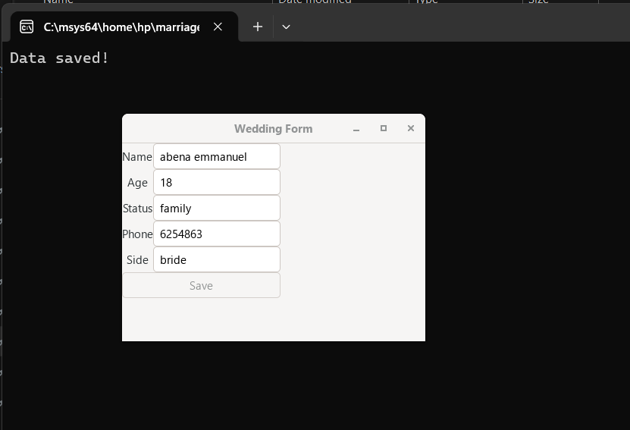
Csv file creation

The csv file was generated immediately after the GTK form worked, and was tested by inputing arbitrary entries

- Problem Encountered and Solution

General Problem
- Difficulty in configuring development tools such as GTK.
- Limited understanding of UML diagrams (sequence, deployment, use case, class).
- Challenges in using StarUML (navigation, relationships, layout).
- Errors in coding such as file handling, compilation, and signal connections.
- Complexity in organizing system interactions and component communication.

General Solution
- Proper installation and configuration of development tools.
- Studying UML concepts and applying correct diagram rules.
- Practicing and exploring StarUML features for better usage.
- Applying debugging techniques and correct coding practices.
- Breaking the project into smaller tasks using structured planning tools like Gantt charts.
- Conclusion
The Wedding Ceremony Management System demonstrates how C programming can be combined with project planning tools, system design diagrams, and user interface technologies. The use of GTK and CSV enhances usability and data management, making the system efficient and practical for real-world applications.

PERSON AND CATEGORY MANAGEMENT: IMPLEMENTATIONS & TESTS
Person Management
This module concerns the registration of the guests at a wedding ceremony, alongside all the operations carried out on them (Entry, Update, Delete). The previous model in the second report being lacking, the following is an update version
- The c-program was written and thoroughly debugged using dev c++ software

Extract of Person Management C-code

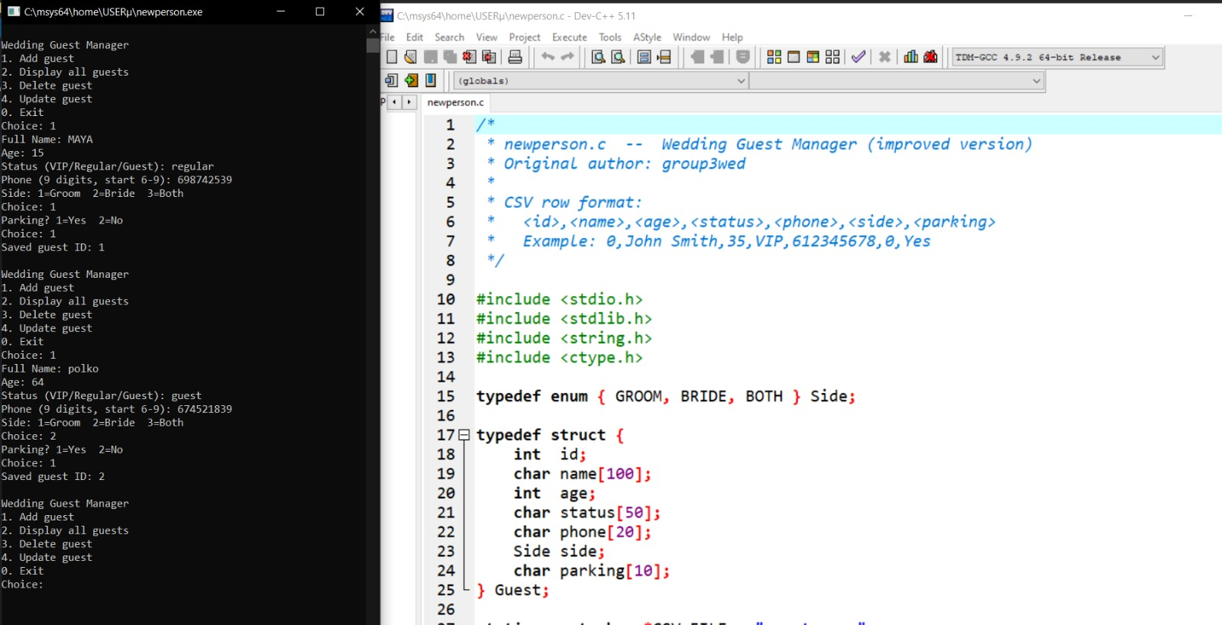

- Once written, the c-program was converted into a GTK form using GTK-specific libraries

Extract of person management GTK c-code
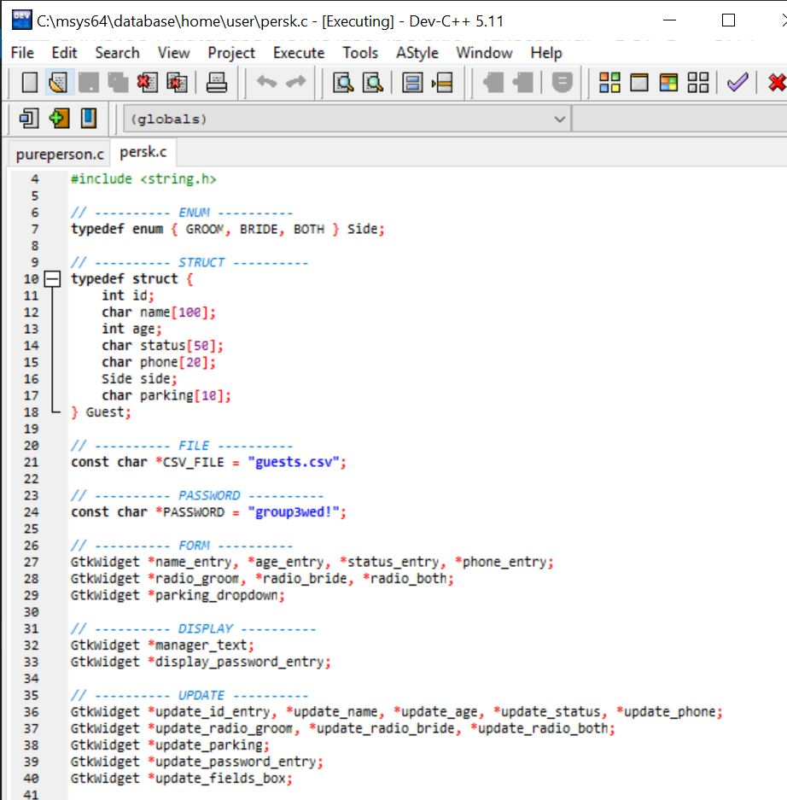

- The csv file was automatically generated below the gtk person management file immediately the gtk compiled successfully.

GTK ran successfully

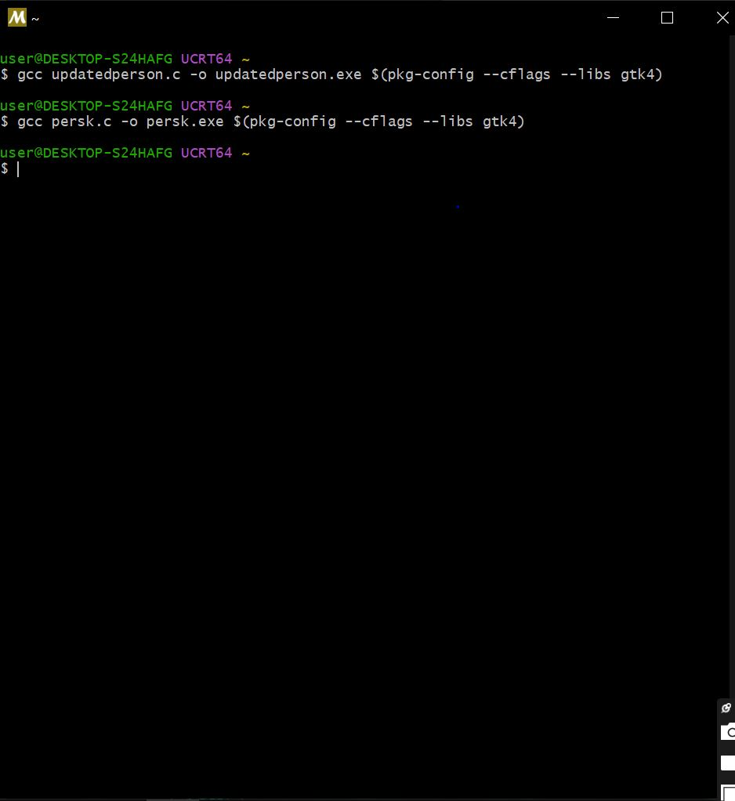

Csv file

- Tests were carried out to verify that the Person management form performs its job correctly

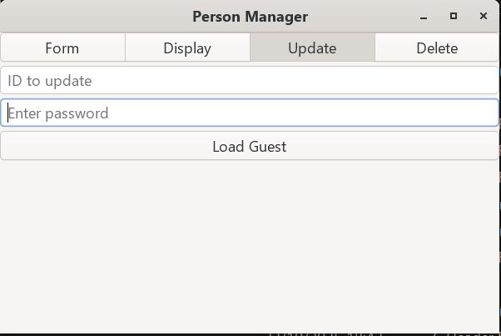
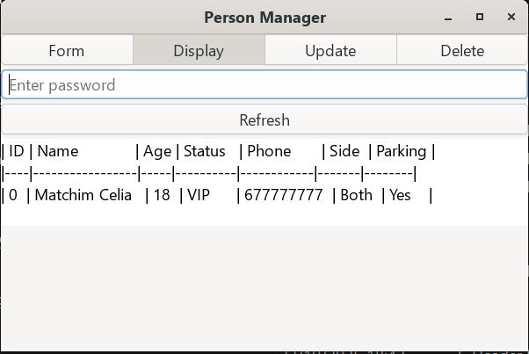
  - Person registration (b) Person update

Category Management
The category management module was implemented in order to allow for creation of different categories at a wedding ceremony.
-Just like the person management module, alongside all the operations (Display, Update, Delete, Assign Guests)
- For assigning guests, the code was linked to the person management code, through the ID
- The code was thoroughly debugged using dev c++ software

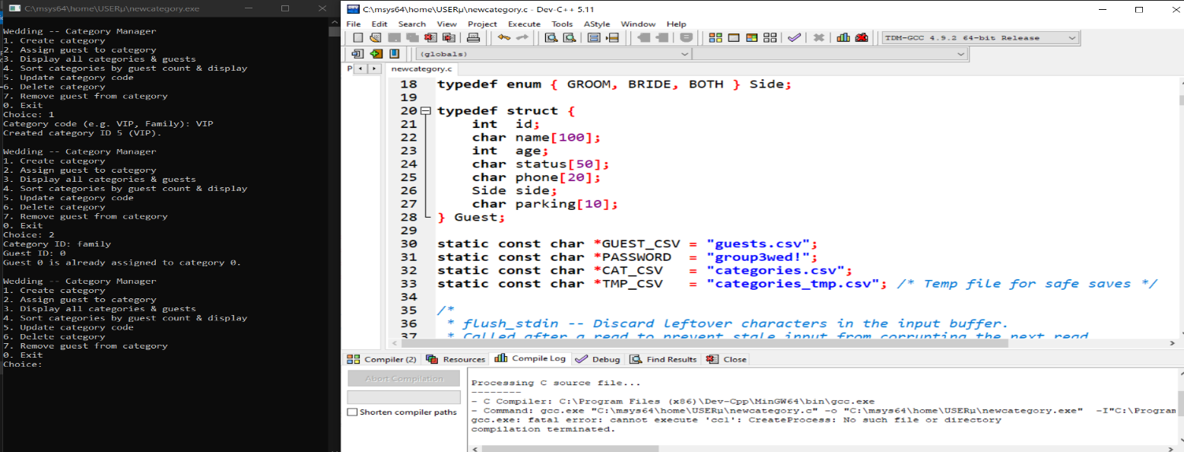
Extract of Category Management C-code
- Once the category management c program was correctly implemented, the GTK form version was created.

Extract of Category Management GTK code
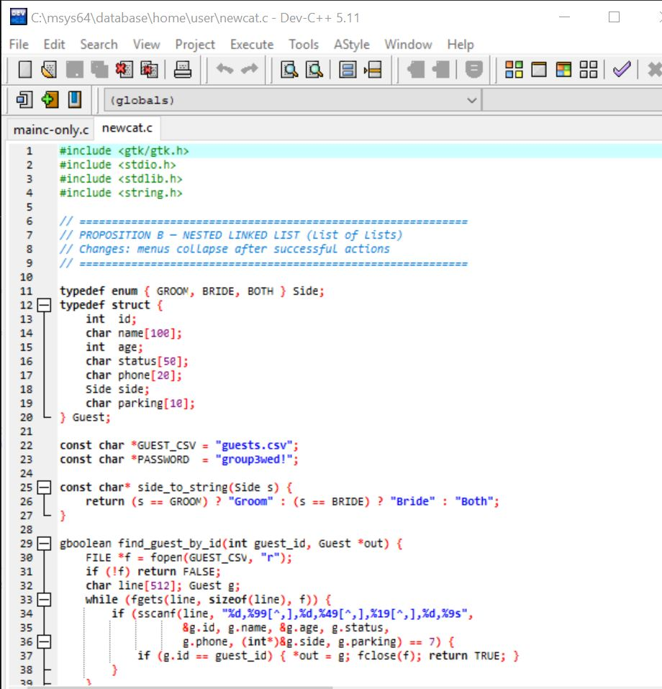

Haven properly run the code, the csv file was created automatically below the category management.

Category ran successfully
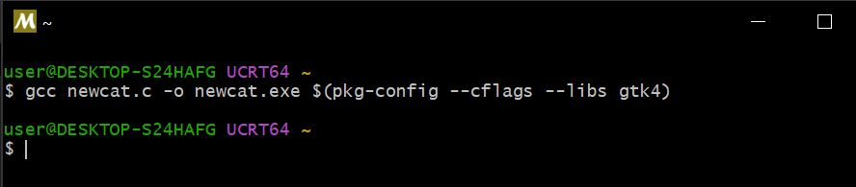

Csv file

- Haven properly created the csv file, test were carried out, similarly to those in the person management, to ensure functionability

Category Manager Window
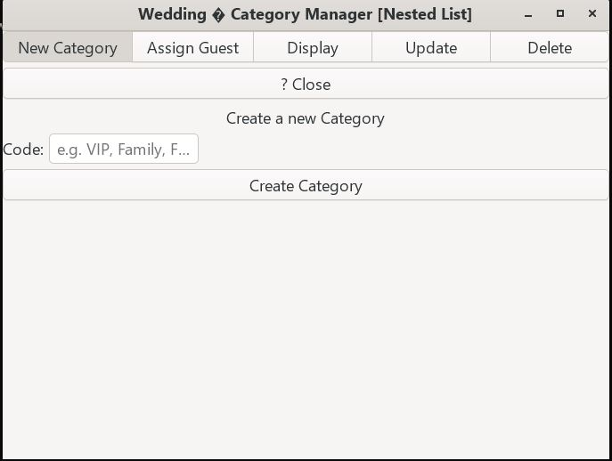

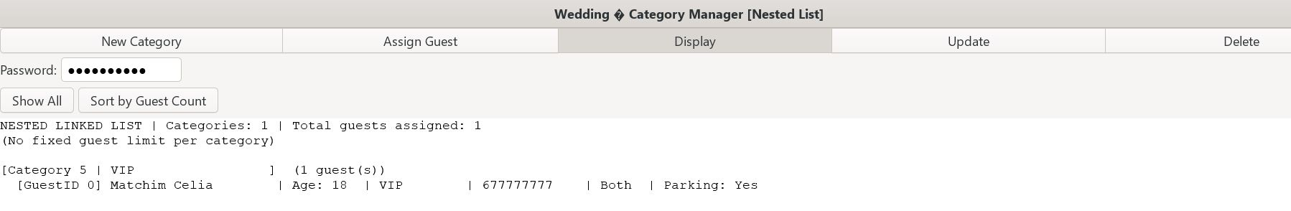
Assignment Page

COMBINATION OF PERSON AND CATEGORY MANAGEMENT ONTO A SINGLE WINDOW
Haven made the person and category management fully-functional; it is necessary to combine them in a single window where a user has the possibility of choosing which to fill.
- The c-code, mainapp, was written, thoroughly de bugged and converted to a GTK form, and the csv file generated subsequently

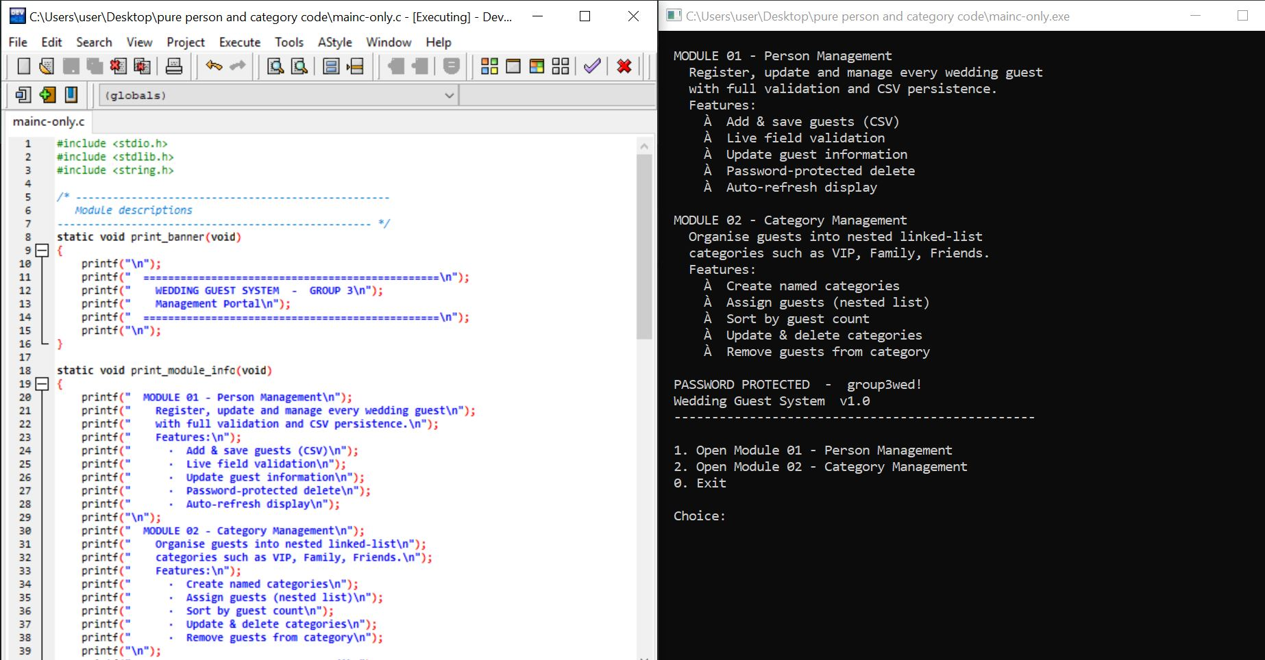
Main code with c only

- Css was added to the GTK inorder to beautify the window

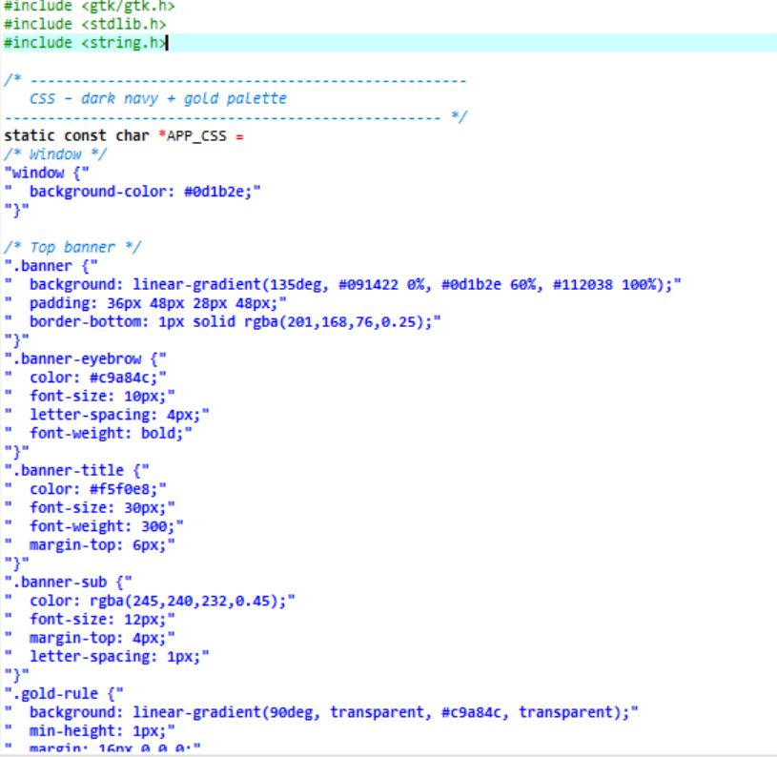
Extract of Main code with Css

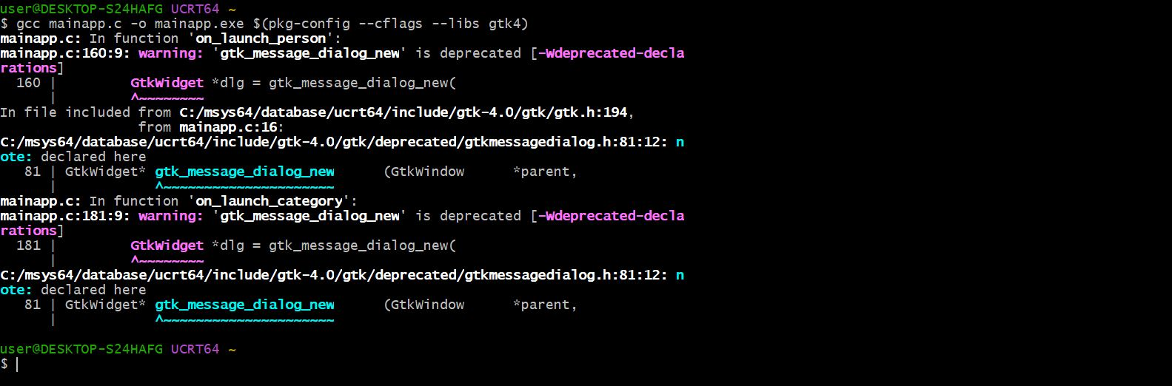
mainapp ran Successfully

Csv file

Main Window
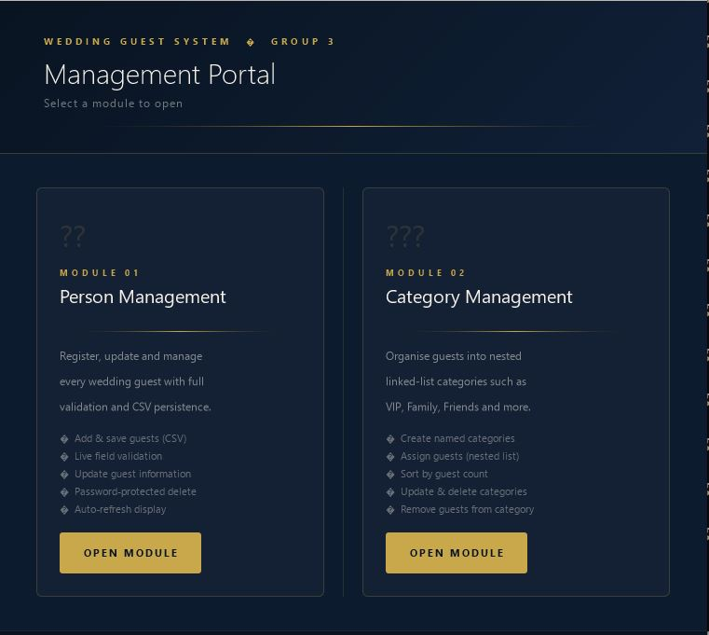

NB:
- A password was used to prevent guests from accessing fields other than registration. Password: group3wed!
-For being lengthy, full codes could not be integrated in our report. Full codes are available in the GitHub repository at this link: https://github.com/celia-pixel-rgb/Project-Wedding-Ceremony
- All the outputs of the codes are present in the repository too.

CONCLUSION
With Modules 1 and 2 successfully implemented, we are ready for the implementation of subsequent modules.

